Self-Healing Infrastructure with Prometheus, Alertmanager & Ansible

Overview of the servers:

Server | Purpose | Components Installed | Example Hostname
Server 1 | Monitoring Server | Prometheus + Alertmanager | monitor-server
Server 2 | Application Server | NGINX (sample service to monitor) + Node Exporter | app-server
Server 3 | Automation Server | Ansible (will receive webhook from Alertmanager) | ansible-server

Step 1: Launching 3 servers
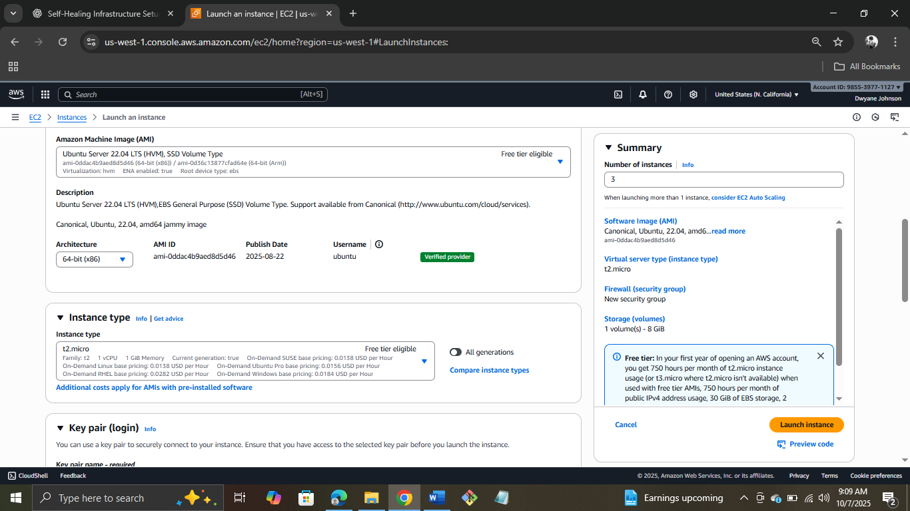
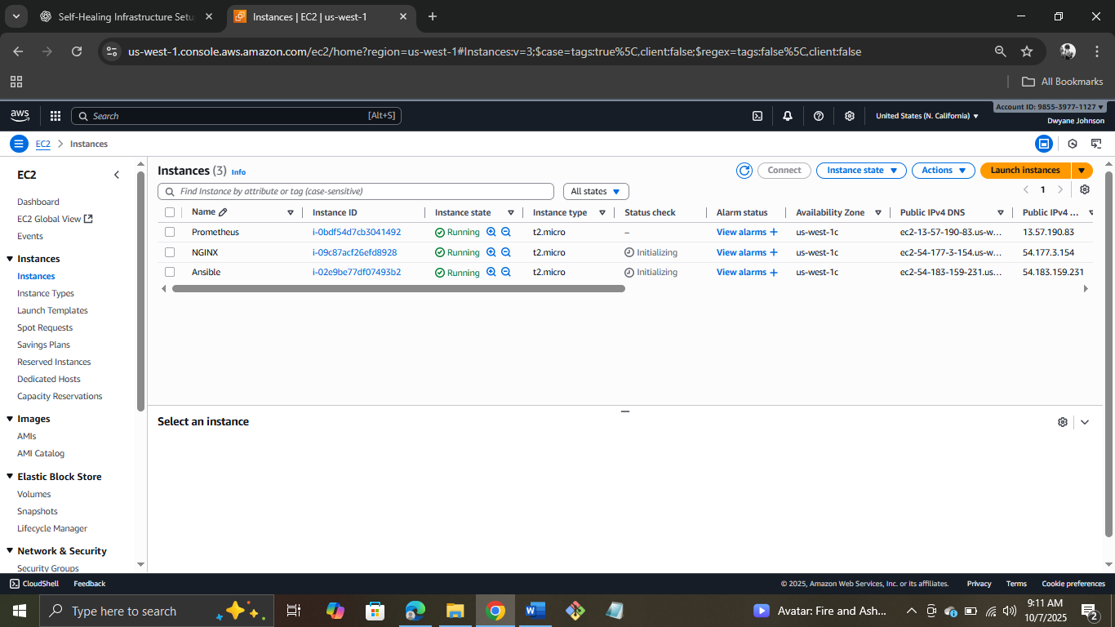

Step 2: Connecting NGINX server to git bash and Installing NGINX and Node Exporter
Installing NGINX


Installing NodeExporter
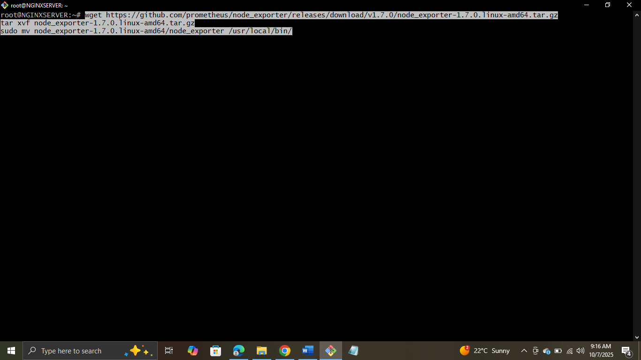
Creating system service
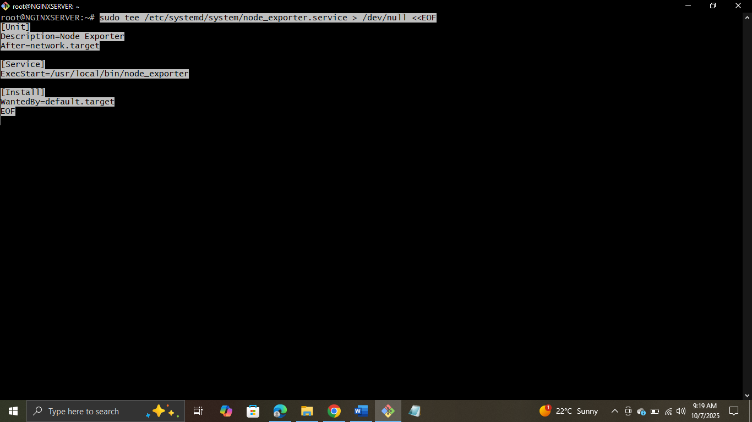

Relaoding, Enabling and Starting Node Exporter
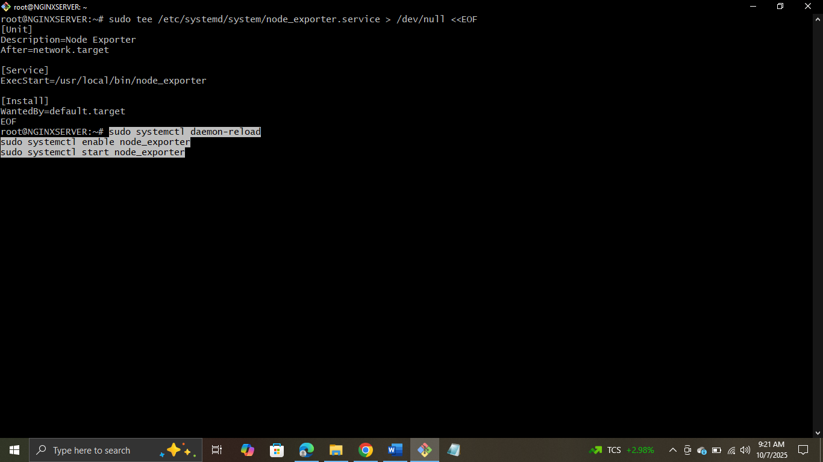
Verifying by taking Public IP
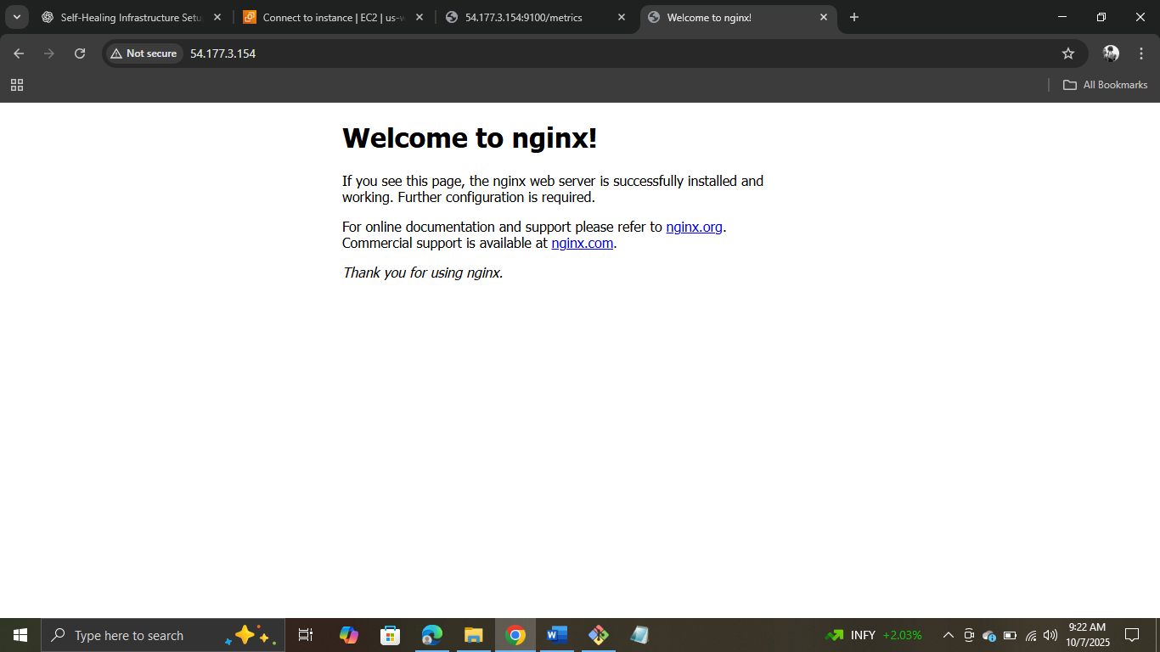
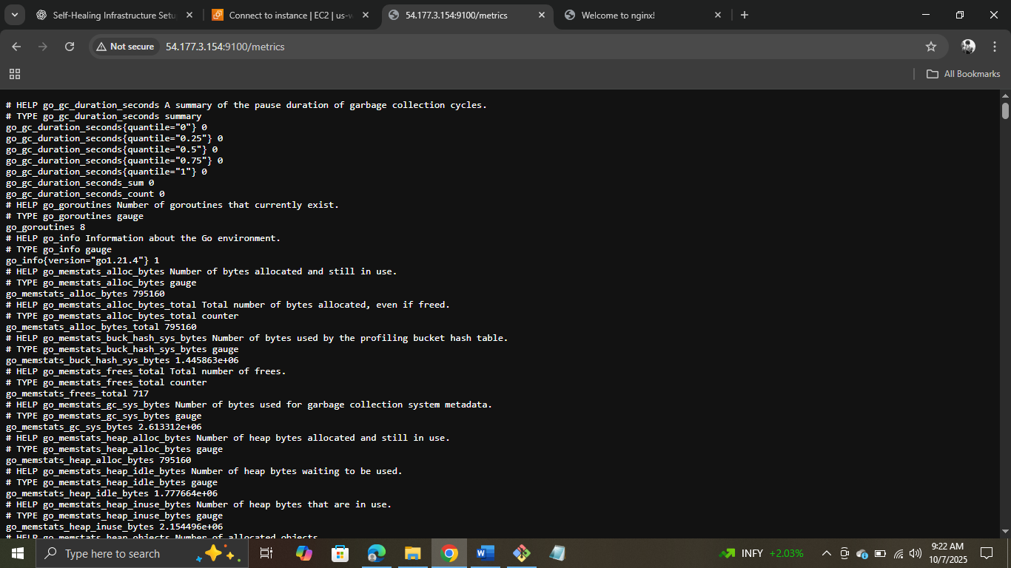

Step 3: Setting up Monitoring Server – Prometheus
Installing Prometheus
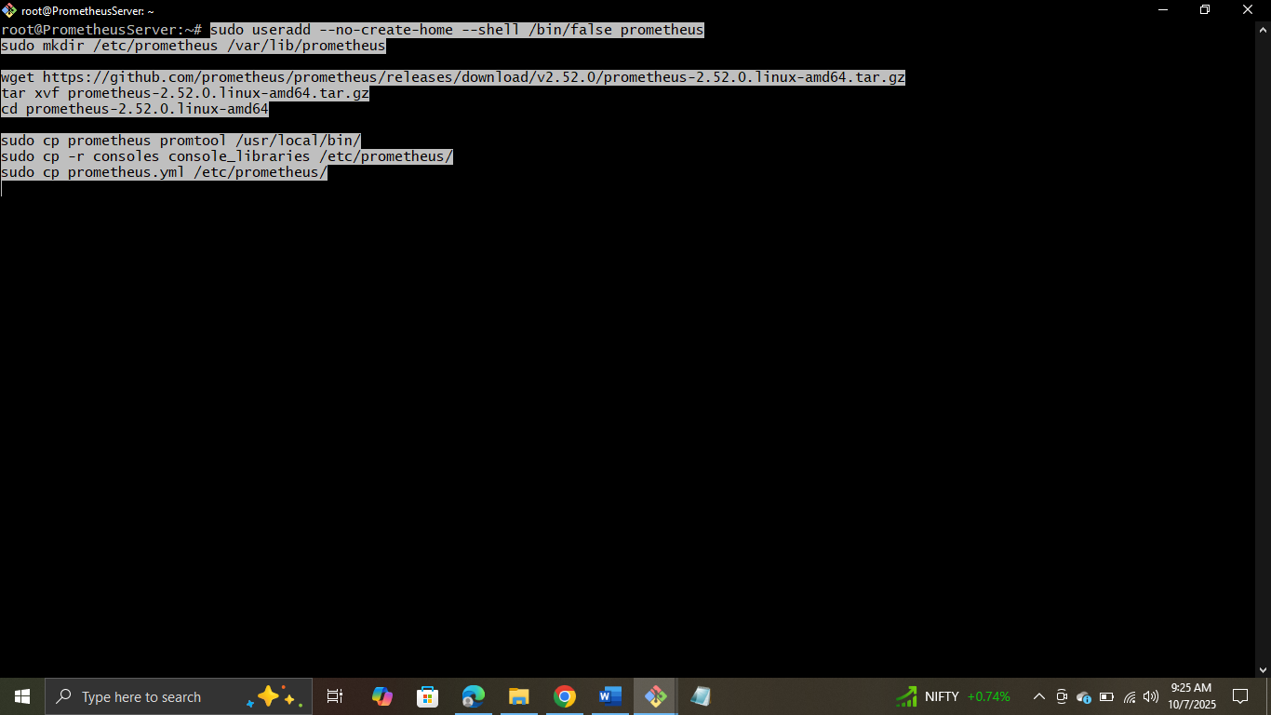

Editing Prometeheus Config – Opening the file
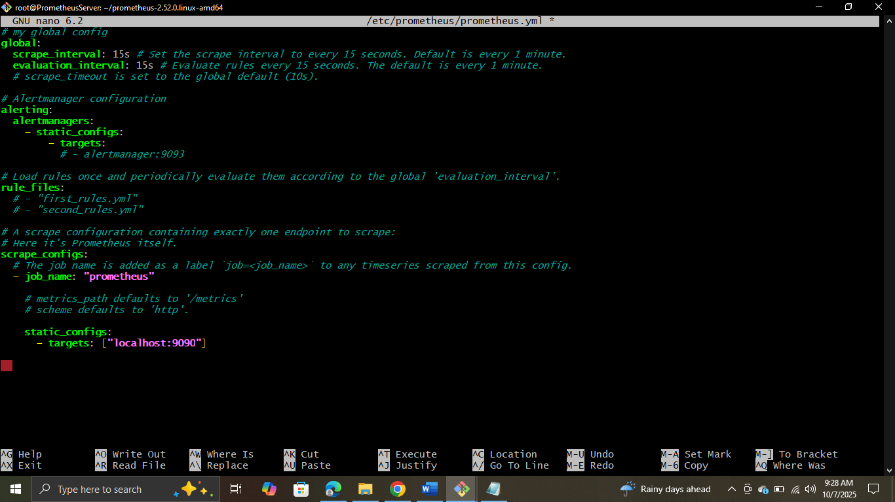
Adding the changes
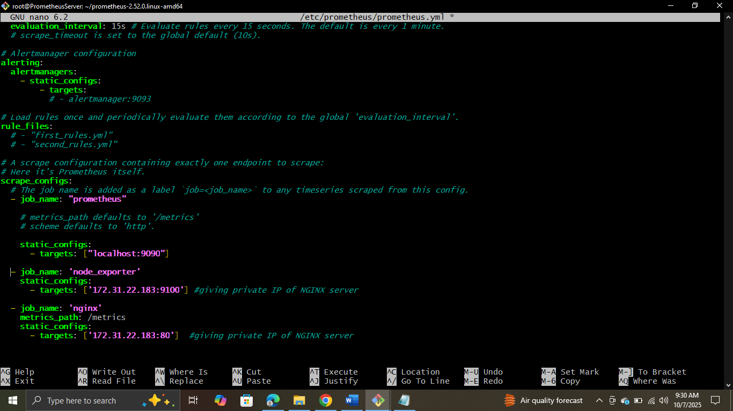

Creating Prometheus Service
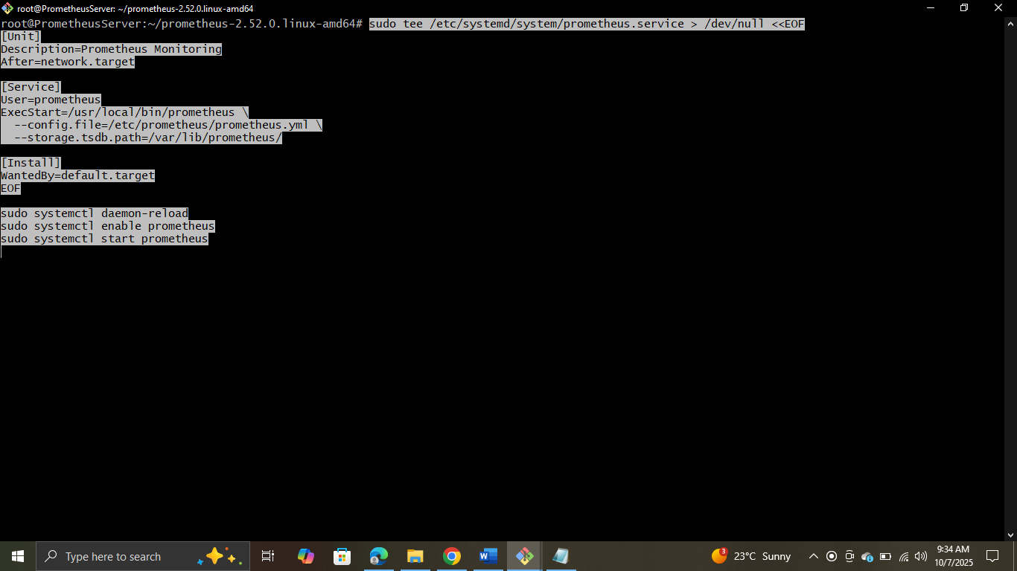
Relaoding, Enabling and Starting Prometheus
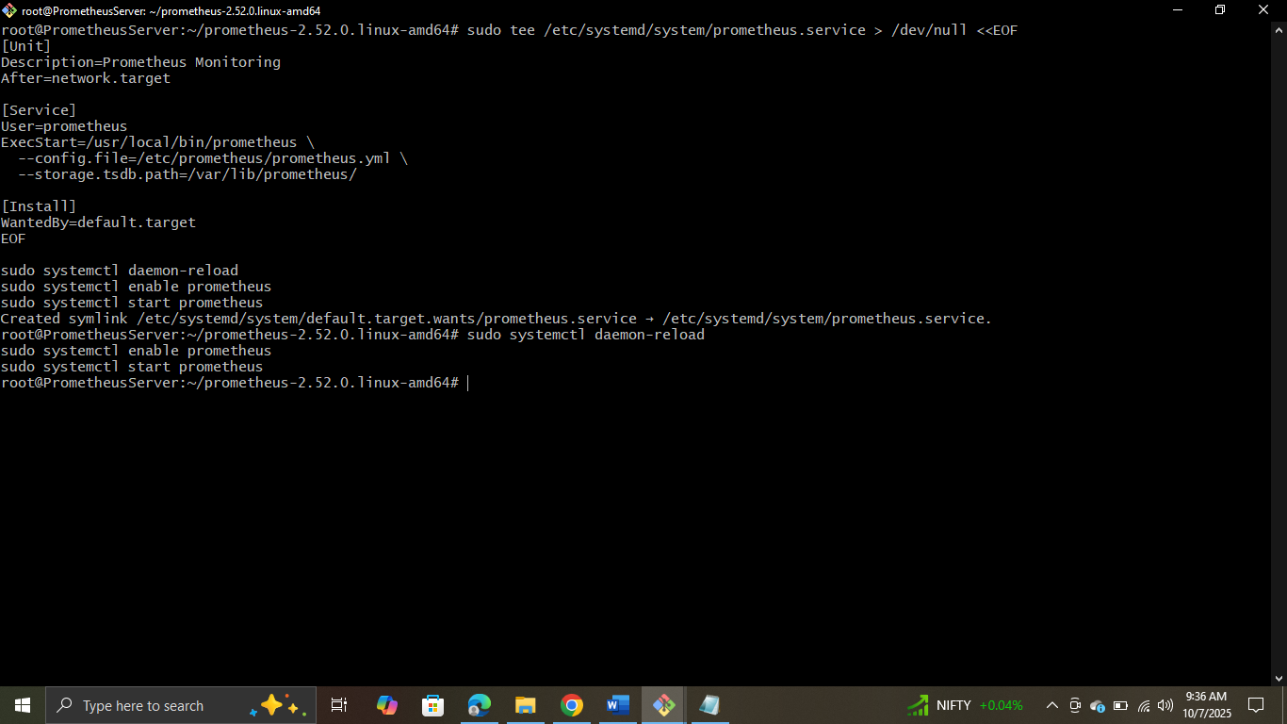

Verifying by taking Public IP: 9090
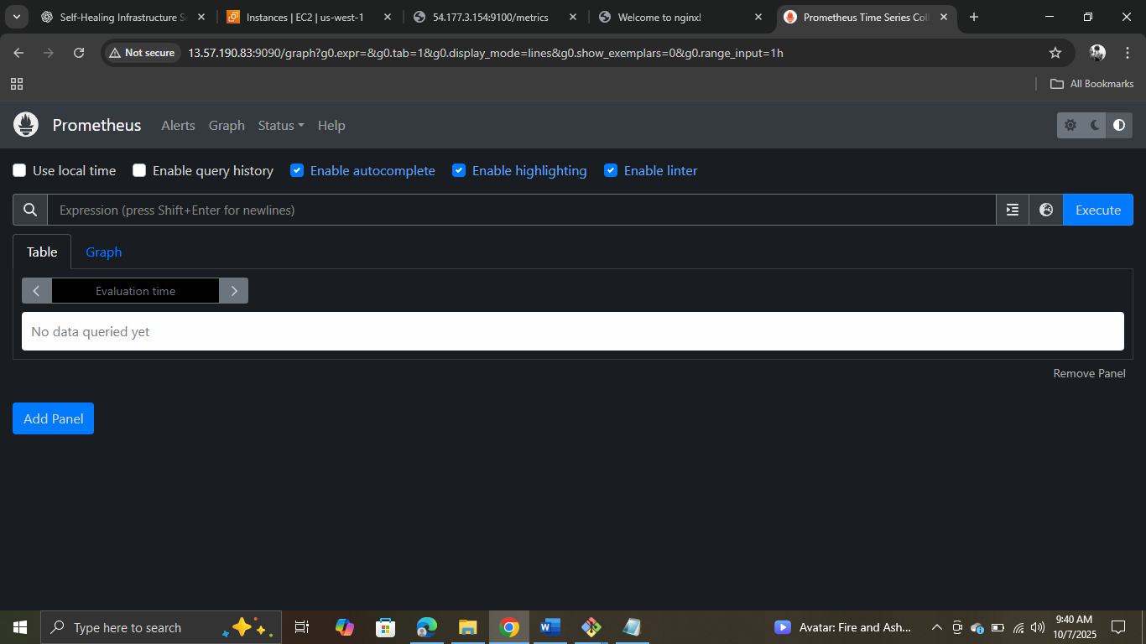

Step 4: Setting up Alertmanager on the same monitoring server
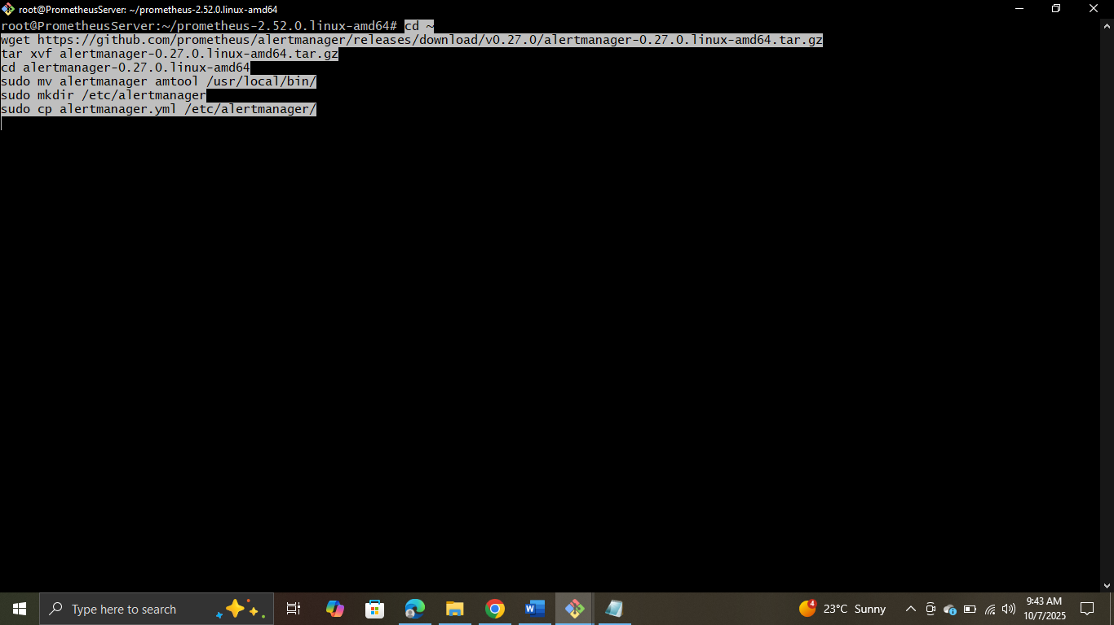

Configuring Alertmanager Webhook

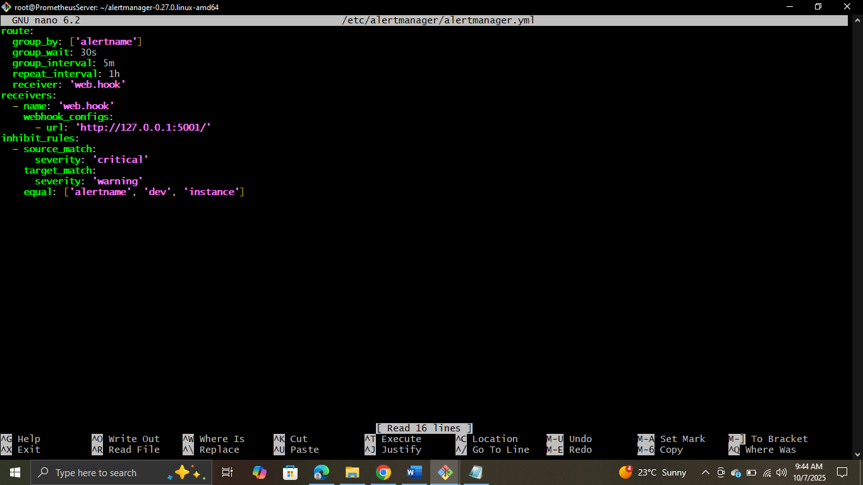

Adding Changes
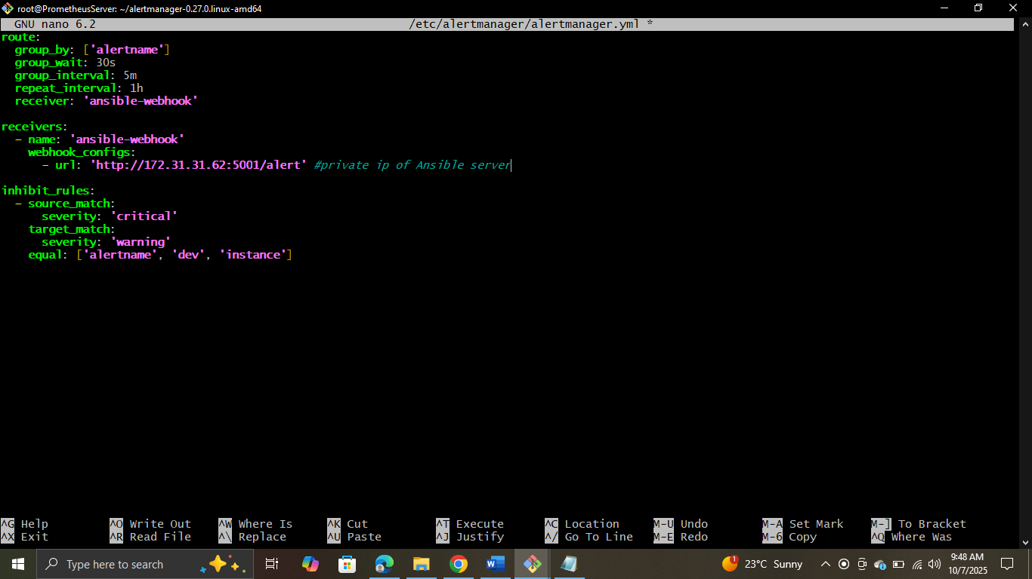
Step 5: Setting up Ansible Server and Installing Ansible and Flask
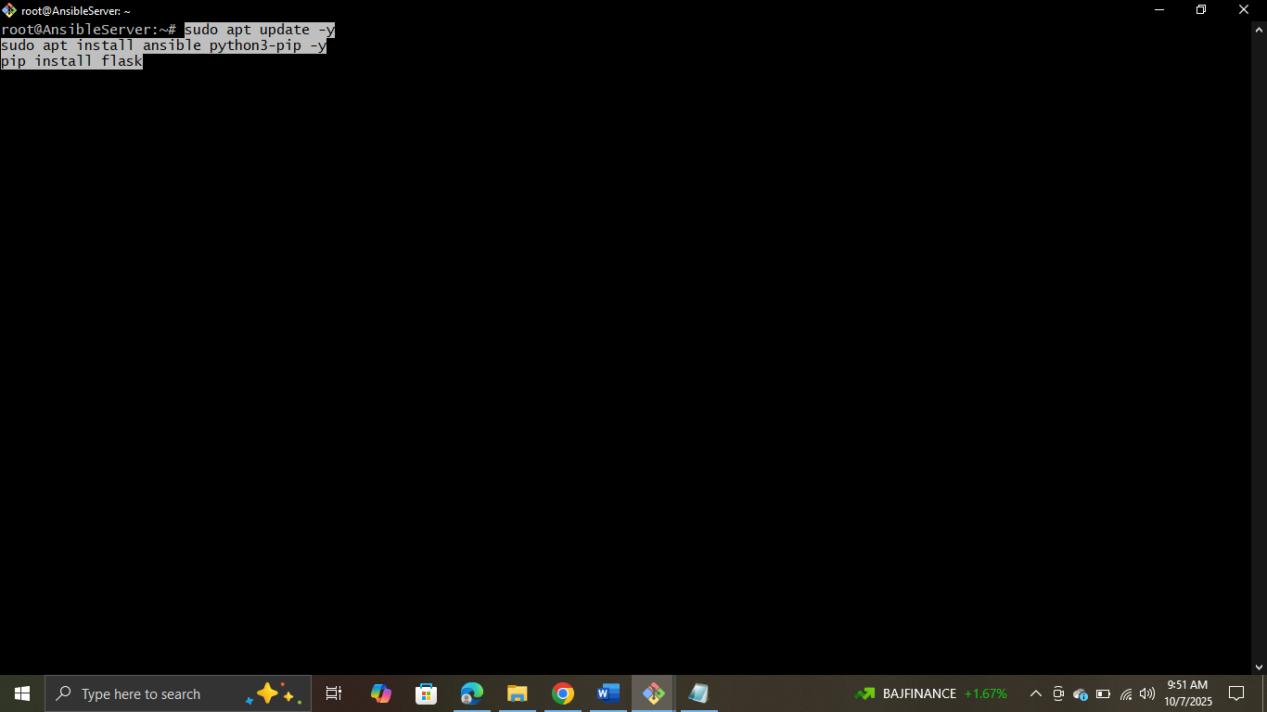

Creating Flask Webhook

Pasting the code (initially this file was empty)
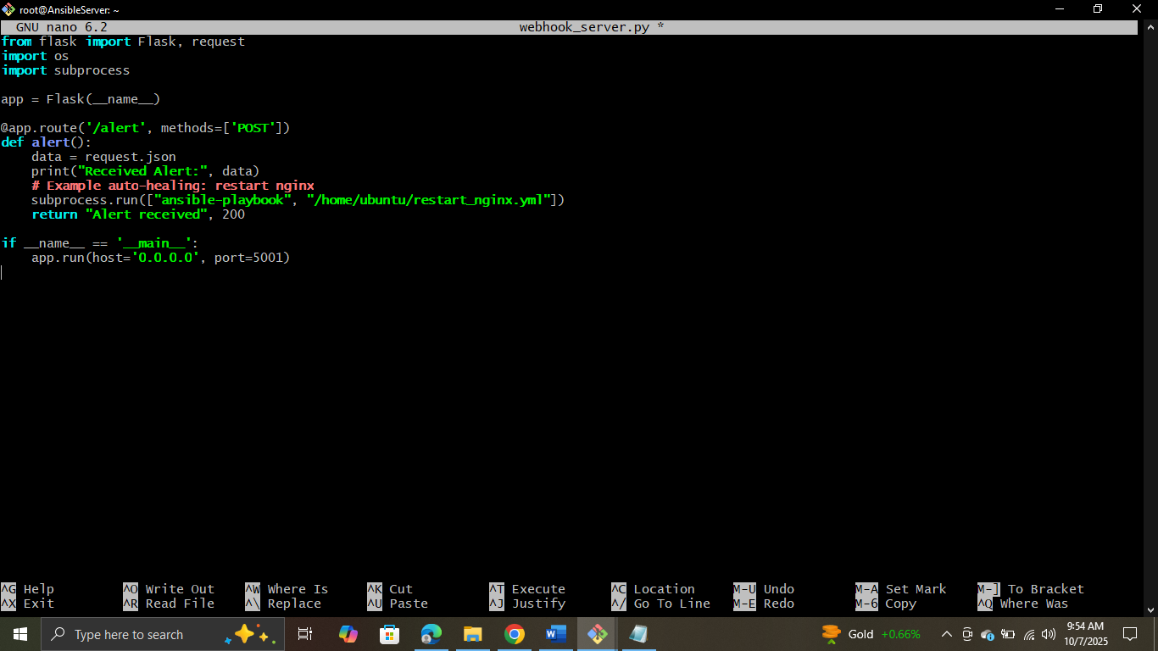

Running the code
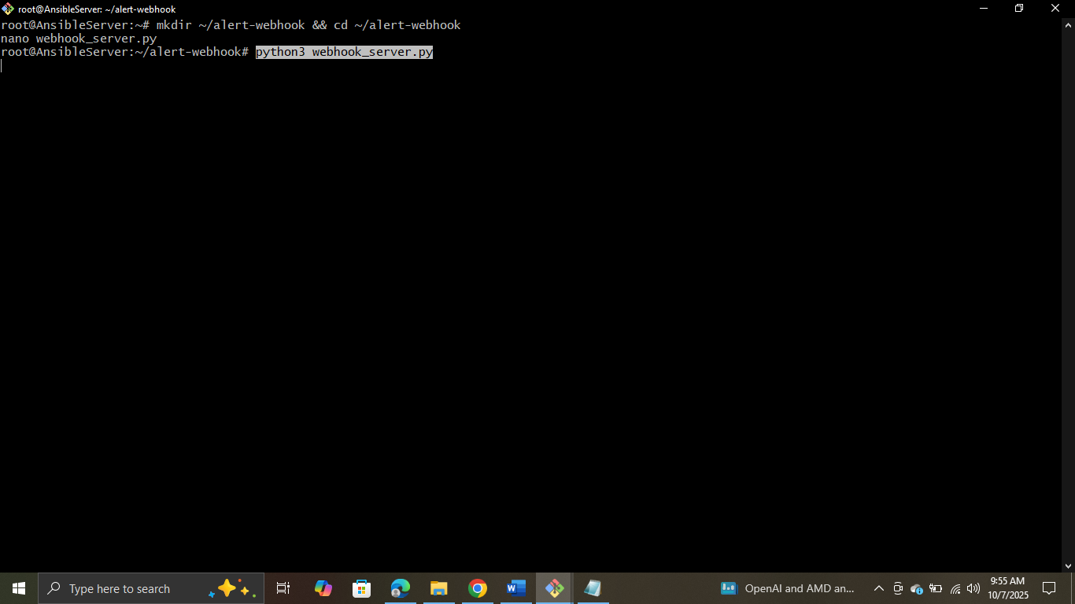
Creating Directory
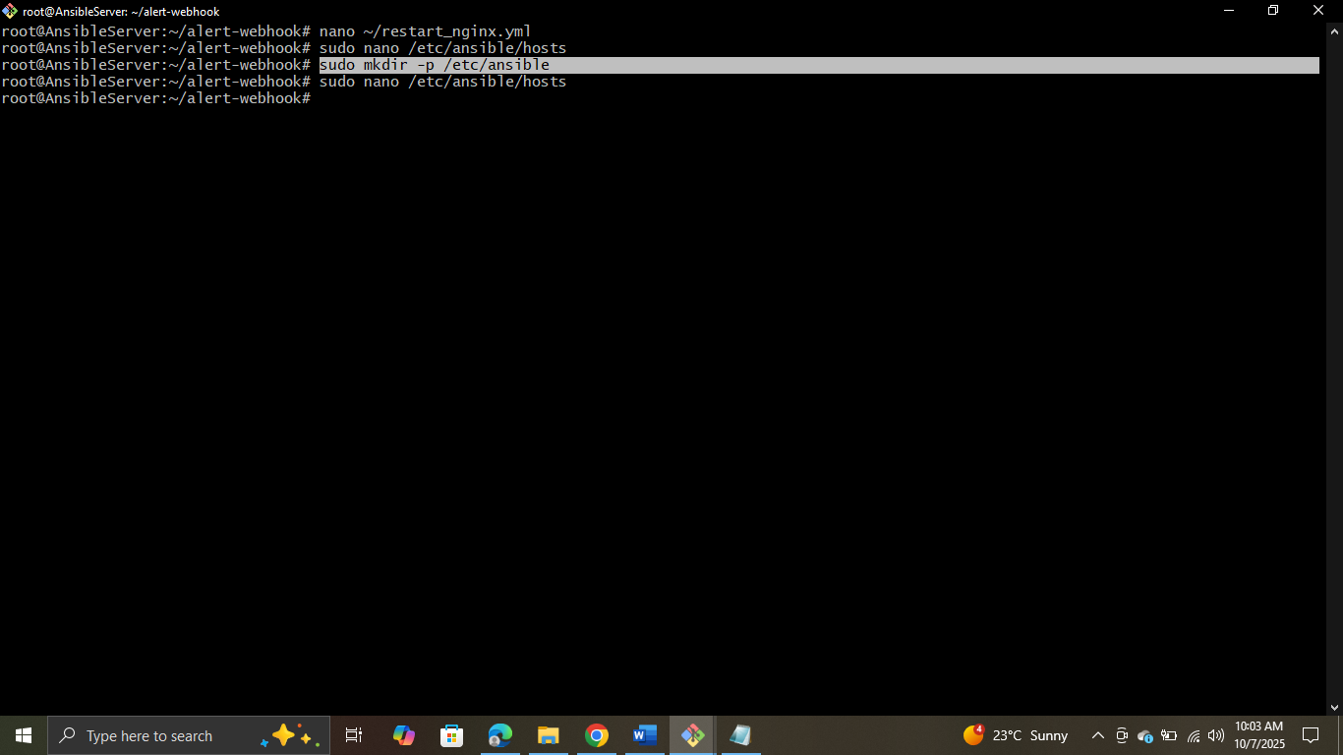

Creating Ansible Playbook


Pasting the code (Initially this file was Empty)
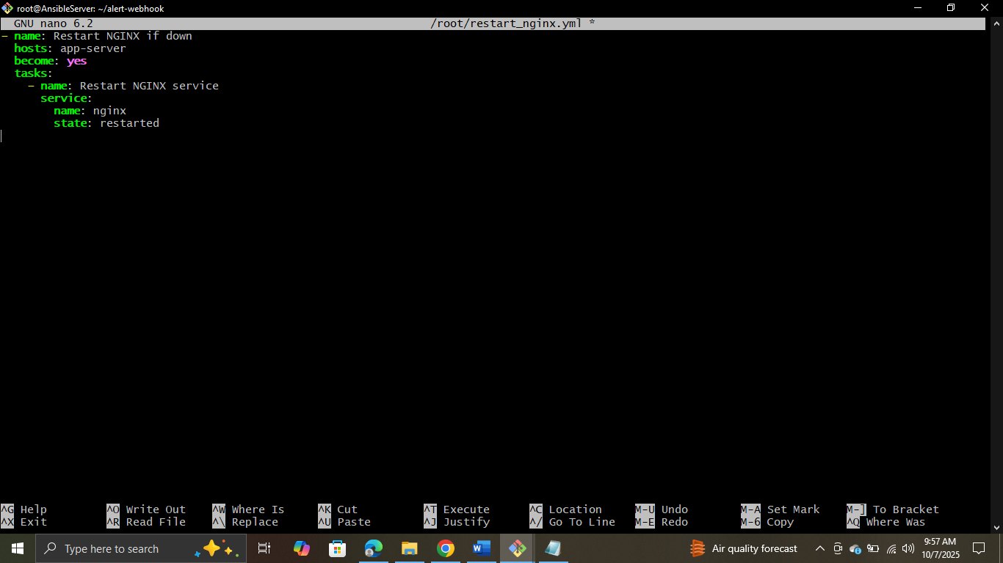

Configuring the Inventory
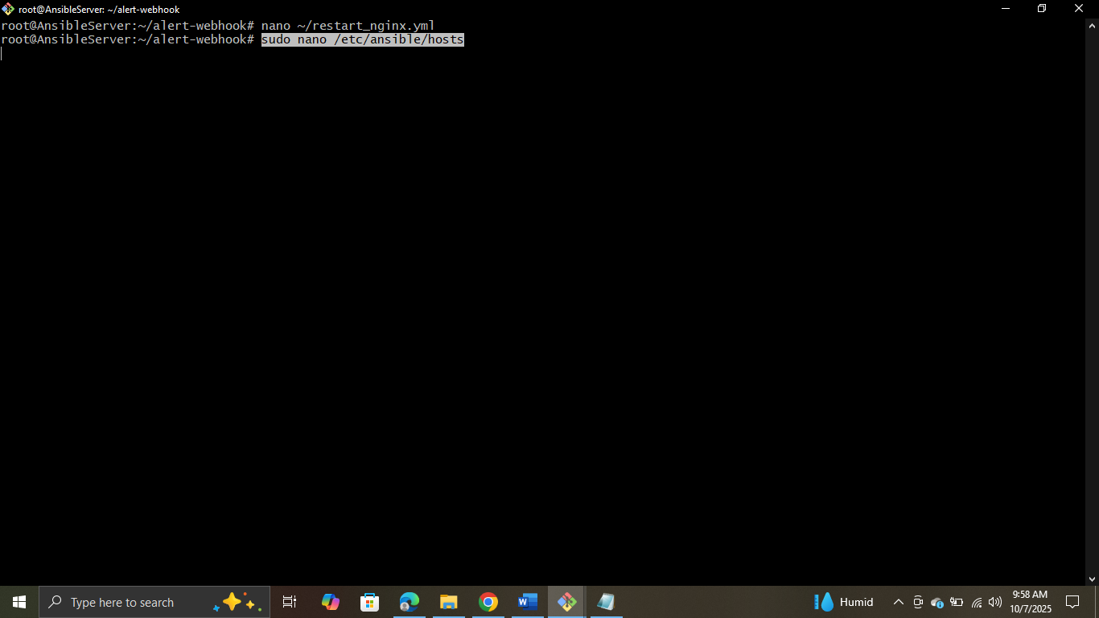

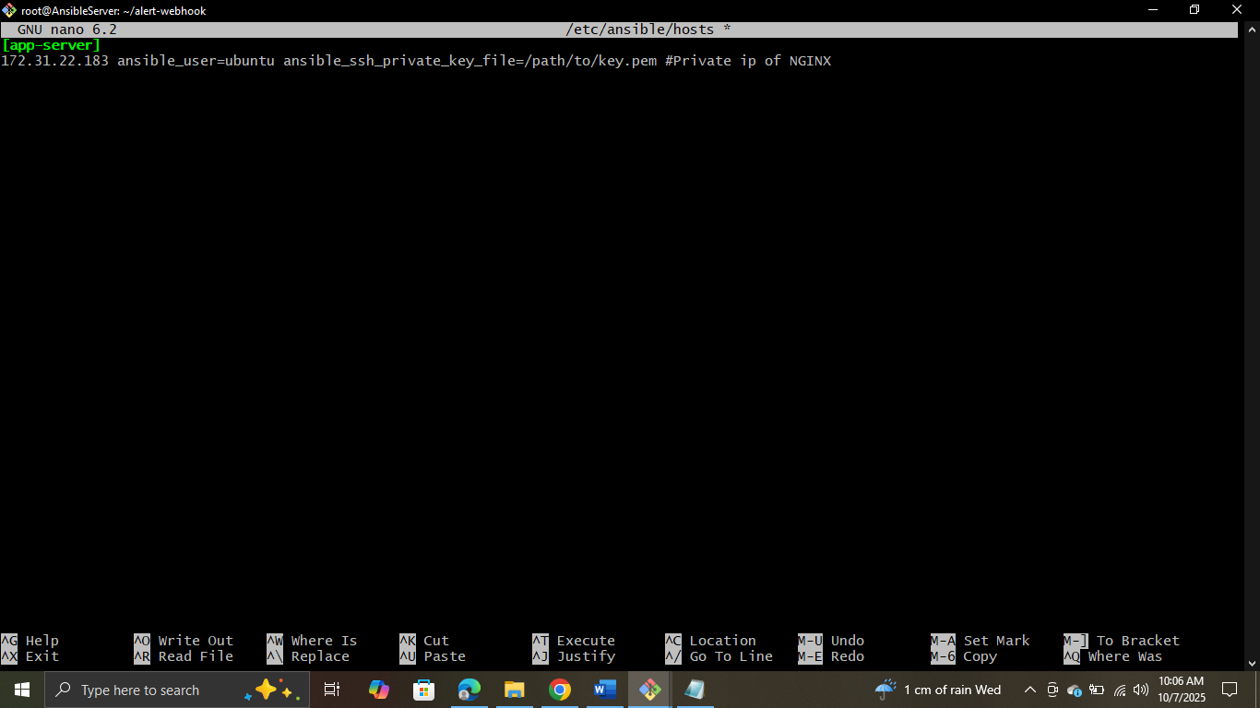

Testing the connection

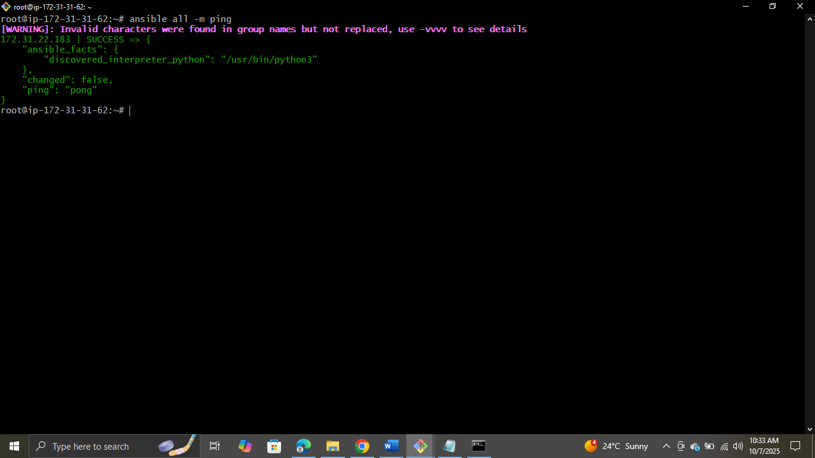

Creating Ansible Playbook
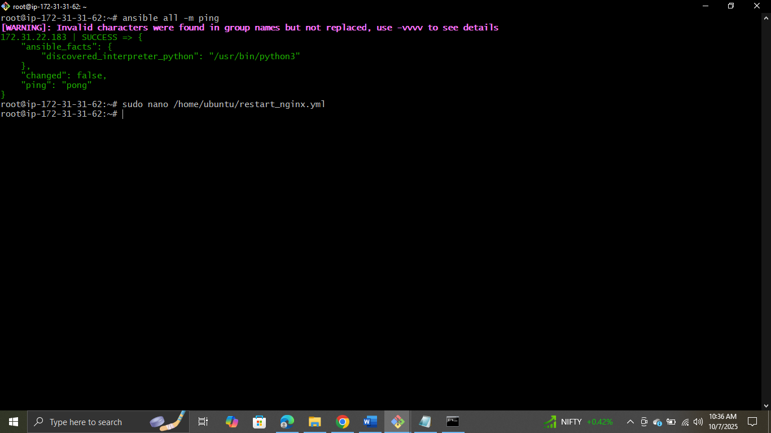
Adding the changes (File was empty)
